Name: B. Krishna
ID NO: 2400030120
Exp: 1
SEC: 09
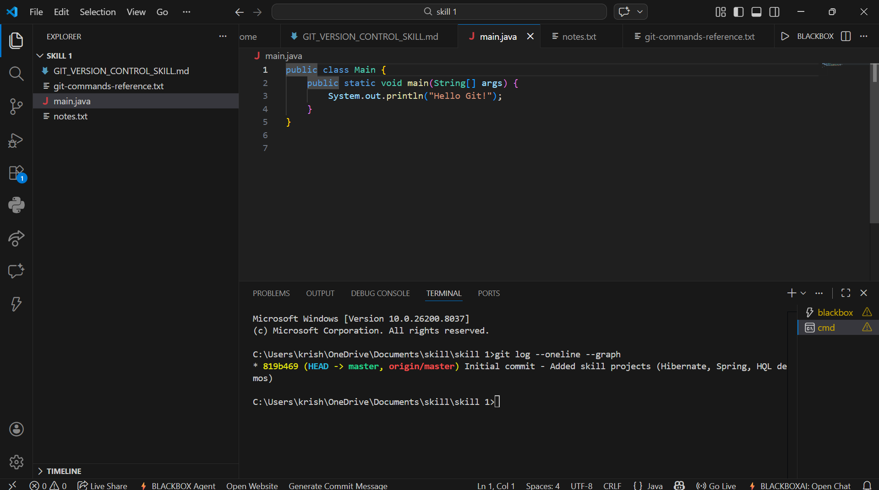
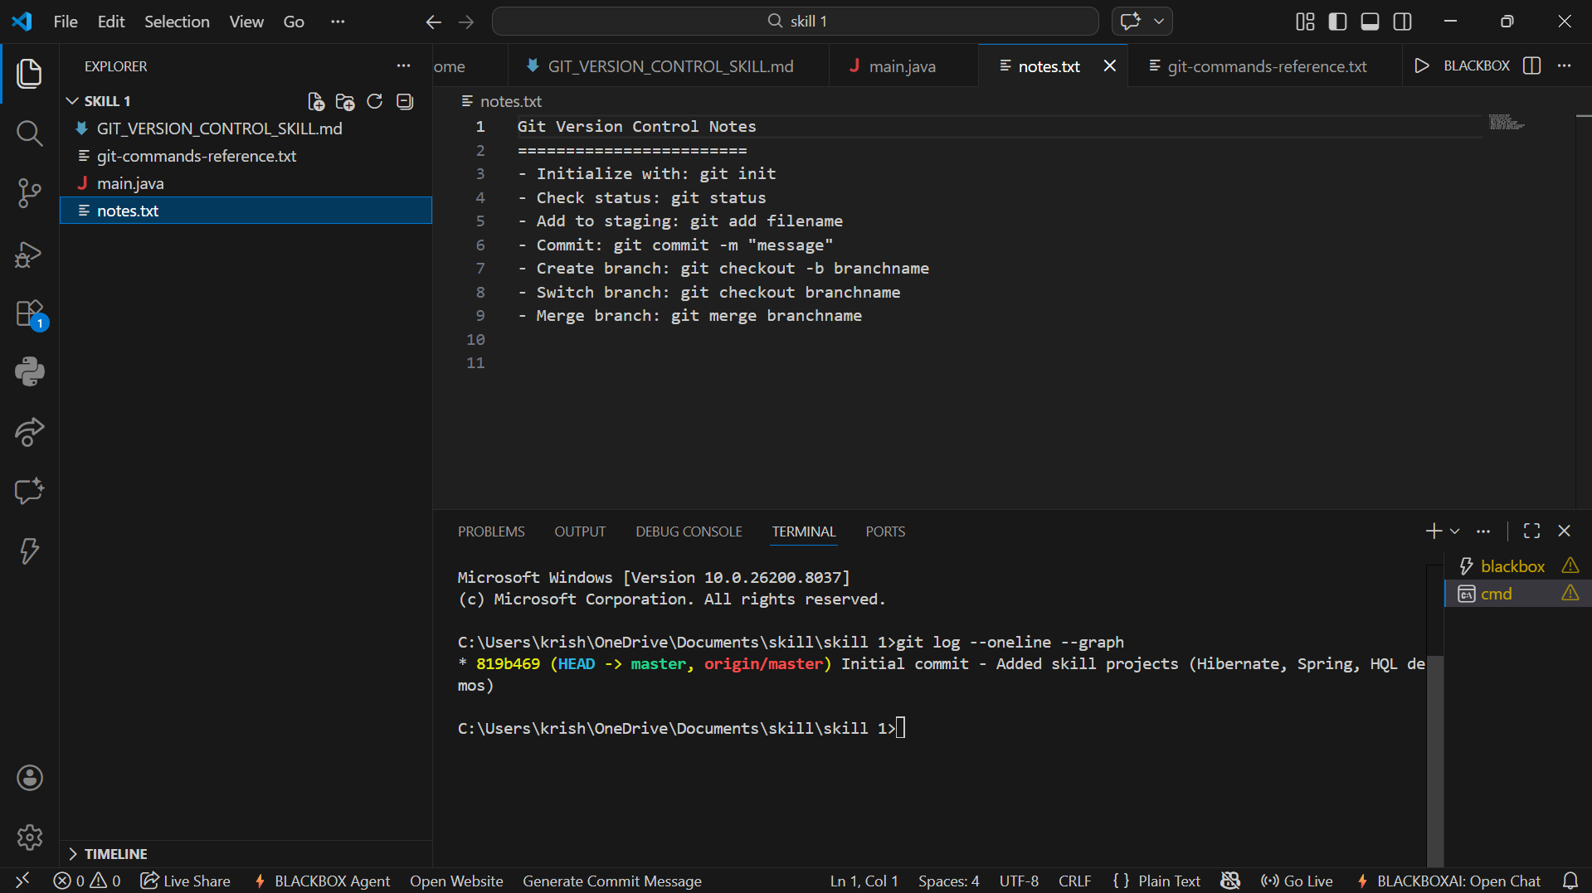
https://github.com/krishna3324/Fsad-Skill.git

